Name: Lovish Kanther

Class: B.Tech Data Science

Semester: VI

Subject: Deep Learning

Experiment: 10 Part (i) – Transfer Learning

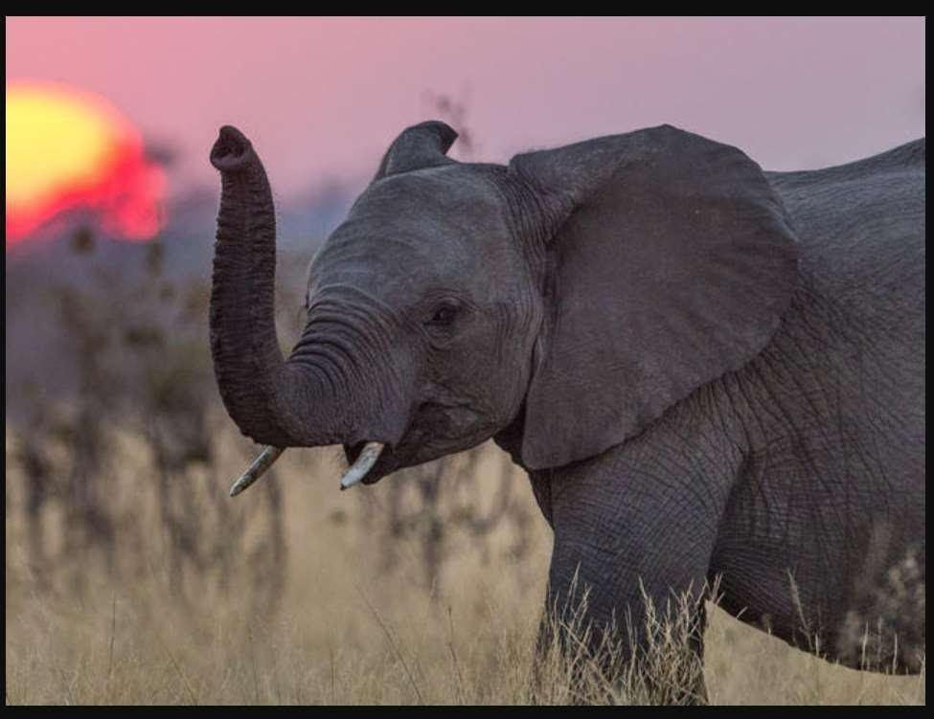

# ResNet50

Predicted: [('n02504458', 'African_elephant', 0.7008188), ('n01871265', 'tusker',

0.22506835), ('n02504013', 'Indian_elephant', 0.074070185)]

# ResNet101

Predicted: [('n02504458', 'African_elephant', 0.5987077), ('n01871265', 'tusker', 0.3783492), ('n02504013', 'Indian_elephant', 0.022769945)]

# ResNet152

Predicted: [('n01871265', 'tusker', 0.45742124), ('n02504458', 'African_elephant',

0.4302972), ('n02504013', 'Indian_elephant', 0.109465055)]

# ResNet50v2

Predicted: [('n02504458', 'African_elephant', 0.8193), ('n01871265', 'tusker', 0.16853635),

('n02504013', 'Indian_elephant', 0.012021563)]

# ResNet101v2

Predicted: [('n01871265', 'tusker', 0.51101893), ('n02504458', 'African_elephant',

0.4643323), ('n02504013', 'Indian_elephant', 0.024492722)]

*Therefore the best model is Resnet50V2, which has an accuracy of 81.93%.*